Sleepify: Mobile Application Development (Communication & Security) Final Report

Lo Ho Shun, Calvin

Department of Electrical and Electronic Engineering, Imperial College London, SW7 2AZ

Email: hsl113@ic.ac.uk

Supervisor: Dr. Yiannis Demiris

# Related Research

## JSON

JavaScript Object Notation (JSON) is a lightweight text-based open standard for serialization of structured data. It is a language-independent data interchange format and human-readable. Its wide availability of implementation allows this data format to replace XML and become the most common way for asynchronous server communication. [1]

## HTTP Networking

The Hypertext Transfer Protocol (HTTP) is a protocol used by worldwide web. It defines the way of messages formatted and transmitted. In response to various commands, this protocol will provide the corresponding actions for the web servers and browsers. [2] The HTTP networking plays an important role in order to provide a communication channel between the backend server and the mobile application.

## Network Security

To maintain the network and data usability and integrity, we need to protect the network infrastructure from unauthorized activities. Data encryption and user authentication are the common methods to protect the user data and authorize user to perform any human-to-machine interactions through any type of networks to access the connected systems and resources. [3]

Cross-site request forgery (CSRF) is an attack vector that allow unauthorized commands transmitted by sending arbitrary HTTP requests from a user that is trusted. CSRF vulnerabilities have been known since 2001 and many websites became victim of this type of attack. Therefore, prevention must be made for every communication through internet. There are several CSRF prevention techniques by embedding additional authentication data into requests in order to detect unauthorized usage. [4]

## Temperature and Sleeping Quality

Human body temperature decreases when people are trying to lie on the bed to snooze and initiate sleep. The optimal room temperature is able to improve this action while a cooler room ease people to shut their eyes. It will also help dilating human blood vessels faster to adjust body temperature for sleeping. [5] During the stage of sleep with highest brain activity – rapid eye movements (REM), sleeper usually have dream and it is difficult to wake them up. However, extreme room temperature tends to disrupt sleep as this stage of sleep is commonly more sensitive to temperature. [6] Therefore, the correlation between room temperature and body temperature become the main focus of *Sleepify* project to investigate human sleeping quality.

# Implementation

## Communication

The internet communication is essential to the *Sleepify*’s mobile application and backend server as the system requires large amount of data transmitted in regular time interval when user is sleeping. Alamofire is an HTTP networking library written in Swift for iOS and Mac OS X. It consists of an elegant interface that simplifies loads of Apple’s Foundation common networking tasks. [7] In order to obtain and deliver the physiological data and machine learning algorithm output, we need to use chainable request or response methods to deserializing JSON in both the backend and frontend applications. Alamofire provided various type of GET and POST request API for performing data transmission. By encoding data into JSON format, we are able to upload and download data between mobile application and backend server through implemented URL from the backend. We used NSDictionary class in Swift to set for searching key and obtain the corresponding data from backend. The general communication channels are listed as below:

1. When user wants to register a new account, the corresponding email, username and password will be sent to the backend server.
2. When user logon the system successfully, username will be sent to server for future usage.
3. When start button is pressed, counter will measure the data buffer size and upload the collected physiological data to backend once it is full (every 10 minutes).
4. When stop button is pressed, the total physiological array and user sleeping quality feedback will be uploaded to the backend for further classification.

## Security

In order to secure everyday user’s private sleeping physiological data, we have designed a login system for each user. With this personal account, users are able to utilize their personal username and password to access *Sleepify*’s web interface and mobile application securely. By implementing the Cookie-to-Header Token with backend server, we are able to use this anti-CSRF technique through including the token in the headers of every HTTP requests. We have also setup the AES256-CBC encryption for further protecting every data in future. Once the system is completed, we can use this library to encrypt the data we want to protect.

## Feedback System

As the users woke up everyday, the mobile application will require them to feedback their sleeping quality as good or bad. So that the backend server can classify the physiological data and calculate the optimal body temperature for future usage. Ideally, when the user is sleeping, the backend server will provide an optimal body temperature for the system to adjust the heater every ten minutes. If the user is having a bad sleeping quality at the moment, this optimal body temperature will then compare with the user’s currently body temperature. The system will control the smart plug connecting to the heater with respect of this comparison to achieve the optimal body temperature. If the override button is on, the system will control the heater according to the comparison between the target room temperature and current room temperature. Any changes on body temperature will be neglected. The flow of the system is shown as below:

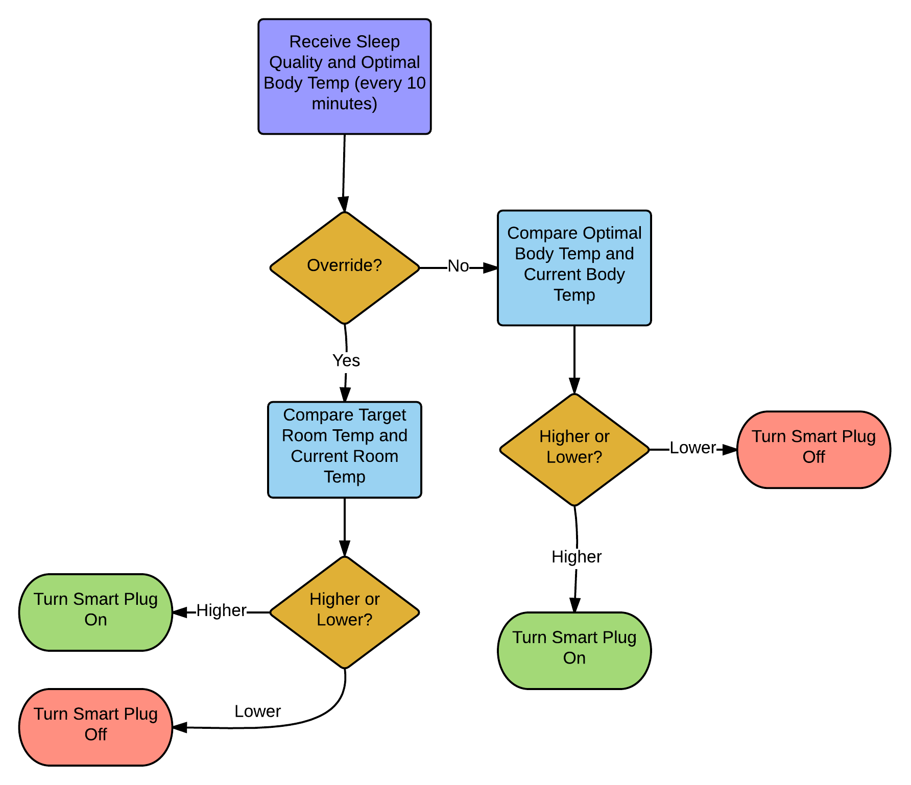

Figure 1 Flow Chart of Sleepify's Feedback System

# Testing

Throughout the implementation, we have reduced the data buffer size from 10 minutes to 10 seconds in order to test our code quicker. By checking the HTTP status code, we are able to detect whether the connection with backend server is successful or failure. The backend server terminal console also allows us to check the correctness of data received. Using a hairdryer instead of heater can change the received body temperature of the Microsoft Band faster.

# References

|  |  |
| --- | --- |
| [1] | Microsoft, "An Introduction to JavaScript Object Notation (JSON) in JavaScript and .NET," Microsoft, February 2007. [Online]. Available: https://msdn.microsoft.com/en-us/library/bb299886.aspx. [Accessed 19 March 2017]. |
| [2] | R. Fielding, J. Gettys, J. C. Mogul, H. Frystyk, L. Masinter, P. Leach and T. Berners-Lee, "Hypertext Transfer Protocol -- HTTP/1.1," The Internet Society, Reston, 1999. |
| [3] | M. Rouse and M. Haughn, "User Authentication," TechTarget, 1 December 2014. [Online]. Available: http://searchsecurity.techtarget.com/definition/user-authentication. [Accessed 20 March 2017]. |
| [4] | Chris Shieflett, "Cross-Site Request Forgeries," Chris Shieflett, 13 December 2004. [Online]. Available: http://shiflett.org/articles/cross-site-request-forgeries. [Accessed 19 March 2017]. |
| [5] | National Sleep Foundations, "Bedroom: The Ideal Temperature for Sleep," National Sleep Foundations, Washington, 1990. |
| [6] | Harvard Medical School Division of Sleep Medicine, "External Factors that Influence Sleep," WGBH Educational Foundation, 18 December 2007. [Online]. Available: http://healthysleep.med.harvard.edu/healthy/science/how/external-factors. [Accessed 21 February 2017]. |
| [7] | Alamofire Software Foundation, "Alamofire Reference," 24 January 2017. [Online]. Available: http://cocoadocs.org/docsets/Alamofire/4.3.0/. [Accessed 22 February 2017]. |
| [8] | OWASP, "Cross-Site Request Forgery (CSRF) Prevention Cheat Sheet," OWSAP, 11 January 2016. [Online]. Available: https://www.owasp.org/index.php/Cross-Site_Request_Forgery_(CSRF)_Prevention_Cheat_Sheet. [Accessed 22 February 2017]. |